DDOS ATTACK DETECTION AND MITIGATION (REAL-TIME DDOS DETECTION AND ADAPTIVE MITIGATION FRAMEWORK USING MACHINE LEARNING)
Scope and Limitations
Department of Computer Science and Engineering, [COLLEGE NAME]
Batch C15 (CSE-C) · Academic year [ACADEMIC YEAR]
Table 1: Project team
S.No. | Student name | Roll number
1 | Mallela Pallavi | 23K91A05E3
2 | Kattoju Durgabhavani | 24K95A0514
3 | Nimmala Rakshitha | 23K91A05H3
4 | Prodhatoor Shashi Preetham | 23K91A05K0

Project guide: V Meenakshi
Chapter and section numbers quoted in the text (for example Chapter 8 or Section 6.2) refer to the full project report, 17.Final Document. Figures and tables in this document are numbered from 1.

1. SCOPE

1.1 In scope
• Detection of volumetric and distributed DDoS traffic as a binary decision (Benign or Attack) on rolling windows of 2 to 120 s (default 10 s).
• Live capture with Scapy on a chosen interface, and a Simulation Mode that generates flood, carpet-bombing and slow-style windows in software.
• Ten shared flow features per window, a 200-tree Random Forest, a distributed-risk score, an explainable four-level severity score and persistence across consecutive windows.
• Temporary application-level quarantine of the top three non-protected sources (40 s, doubled for Critical) with automatic recovery, and rate-limit recommendations for Medium severity.
• SQLite history of detections, quarantines, health samples and settings; host health from psutil; twelve JSON endpoints; a nine-page React console and the original Flask dashboard.
• Offline training and evaluation with CICIDS2017-style flow CSVs, including the real-data evaluation reported in Chapter 8.

1.2 Out of scope
• Enforcement outside the application: no operating-system firewall rule, router, switch or SDN controller is changed.
• Attack generation of any kind: Simulation Mode builds packet records in memory and sends nothing.
• Multi-class attack typing, online learning, ensembles, Banzhaf feature selection and deep models.
• Encrypted-payload inspection, application-layer (HTTP) analysis and per-protocol rate limiting.
• User accounts, roles and multi-tenant operation: the React login is a browser-side demo gate and the API is localhost-only.
• Distributed deployment, high-availability storage and capture at data-centre line rates.

1.3 Deployment boundary
Table 2: Where the system is meant to run
Item | Boundary
Host | One Windows or Linux machine, Python 3.11 or 3.12, CPU only (measured on an Intel Core i5-12500, 15.7 GB RAM)
Network access | Passive sniffing of one interface; needs Npcap and administrator rights on Windows
Servers | Flask on 127.0.0.1:8415, Vite development server on 5415
Storage | One SQLite file, joblib model, JSON and PNG results
Users | One administrator or analyst at a time

2. ASSUMPTIONS
The design and the measurements rest on the following assumptions. Where an assumption could not be checked it is marked.
• CICIDS2017 forward direction maps to the sent features and backward direction to the received features; rates are counts divided by flow duration.
• For live windows, a packet whose destination is a local interface address counts as received, one whose source is local counts as sent, and packets between two non-local addresses count as received (the sensor sees them arrive).
• The default window of 10 s and the default quarantine of 40 s are engineering choices, not values derived from data; both are configurable (2-120 s and 5-3600 s).
• Loopback, the machine's own addresses and 192.168.1.20 (the simulator's local host) are protected and never quarantined.
• An address that is quarantined is not blocked on the network, so later windows can still contain its packets and re-quarantine it after expiry.
• The simulator's traffic styles are a reasonable stand-in for the three behaviours it names (unchecked against real captures).
• The real-data evaluation assumes that the labels of the CICIDS2017 Friday-afternoon file are correct enough to score against, although errors in the dataset are documented [9].
• Latency figures assume the load of the test host (other jobs kept the CPU at 100 %), so they are upper bounds.

3. LIMITATIONS
Each limitation below was found while building or measuring the system, and each is stated with the number that shows it.
1. Synthetic training data in the shipped model. CICIDS2017 was unreachable when the product was built, so the shipped forest was trained on 24,000 rows of a labelled synthetic fallback (flows) plus simulator windows. Its 99.71 % is a figure about that data, not about real traffic; on real flows it scores 71.8 %.
2. Real-data result covers one attack day. The retrained forest was tested on one CICIDS2017 file (Friday afternoon, 225,745 flows). Random 80/20 splits of flows from one capture overlap in time, the block split (99.74 %) is the stricter figure, and CICIDS2017 labels are known to contain errors [9]. Other attack types and other datasets were not tested.
3. Ten features describe a flow, not an attack. The schema is five counters per direction. On the real flows the model leans on packet and byte counts and sizes; it has no TCP-flag, port, inter-arrival or entropy information, so attacks that look like ordinary volume are out of reach.
4. Window length sensitivity. The calibration is for 10 s windows. The Simulation Mode default is 5 s and the screenshots were captured at 2 s, where the forest label alone has 46.0 % false positives on benign windows; only the severity layer keeps the acted-on rate at 6.77 %.
5. Mitigation is an application-level denylist. Quarantine adds an address to a list inside SentinelFlow for 40 s (80 s for Critical). apply_os_firewall_block() is a stub that returns applied: false; no packet is dropped anywhere. Rate limiting is only recommended.
6. Live capture was not run end to end. Scapy capture needs Npcap and administrator rights. Neither is available on the test machine; the start request returns 200, the status endpoint reports the real driver error and the mode returns to stopped. All performance numbers come from real flow files and from the simulator.
7. Simulator windows are not real attacks. Flood, carpet-bombing and slow-style windows are generated in software with fixed address pools and sizes. The forest was trained on windows from the same generator, so near-perfect scores on fresh simulator windows say little.
8. Landing page headline. The landing page shows 99.71 % F1 without a caveat; only the Model page carries the 'synthetic training data' warning.
9. Inference cost of the saved forest. The forest was saved with n_jobs=-1, so classifying one window costs a median of 313 ms on the loaded test host against 33 ms with one worker.
10. No authentication on the REST API; unvalidated interface name. The API binds to 127.0.0.1 only and the React login is a browser-side demo gate. The interface setting accepts a 5,000-character string. 25 of 25 other probes behaved as intended.
The first two figures show the limitation that matters most. Figure 1 compares the shipped model on its own synthetic split with the same model on real flows and with the forest retrained on real flows. Figure 2 shows how the false-positive rate depends on the window length, with and without the severity layer.
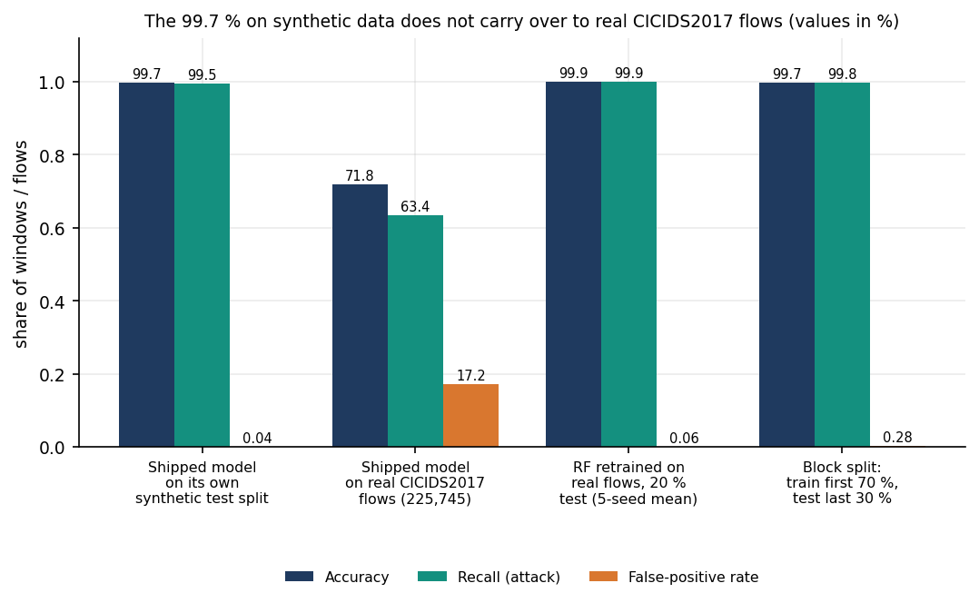
Figure 1: Accuracy, recall and false-positive rate: shipped model on synthetic data and on real flows, and the forest retrained on real flows.
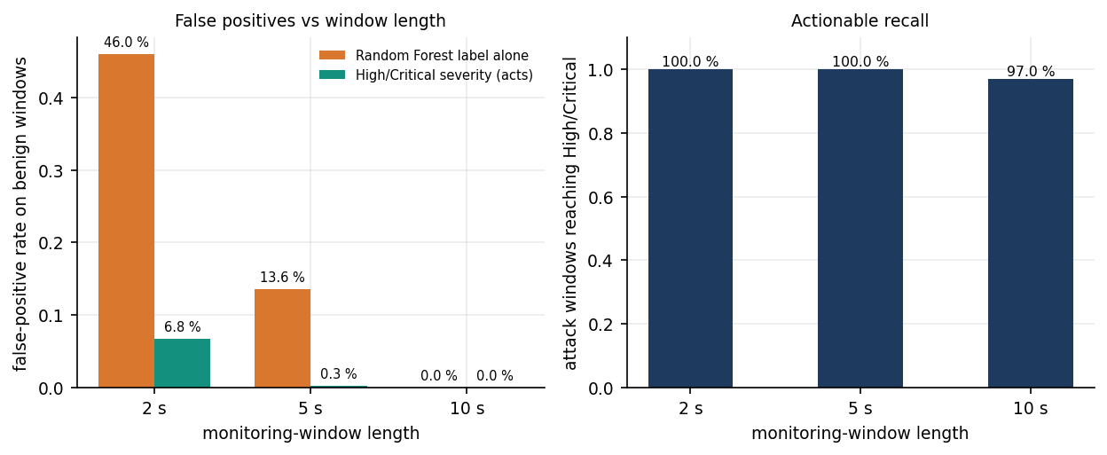
Figure 2: False-positive rate on benign windows and attack recall at 2, 5 and 10 s windows, forest label alone against High or Critical severity.

4. WHAT WAS NOT MEASURED
Gaps are listed instead of being filled with plausible numbers. Each row says why the quantity is missing.
Table 3: Quantities that were not measured
Quantity | Reason
Live packet capture on a real interface | Npcap and administrator rights are missing; only the error path was exercised.
Time from the first attack packet to the first quarantine | Needs a real attack against a live interface; only the decision latency after a window closes was measured.
Recovery time of a real service | Quarantine does not drop traffic, so there is no service to recover.
Real carpet-bombing traffic | Only the simulator's carpet style (many destinations, 10-45 attacker addresses) was scored.
Other CICIDS2017 attack days, CIC-DDoS2023, SDN datasets | Only the Friday-afternoon DDoS file was obtained.
Multi-class attack typing, online learning, ensembles | The product is binary and trained once; the base paper's four voting ensembles and Banzhaf selection were not implemented.
Behaviour under sustained packet load | Largest simulator window was 8,966 packets; capture throughput of Scapy at line rate was not measured.
Usability with real administrators | No user study; the console was exercised by the team only.
Security review of the API | Malformed-input probes only; no authentication, rate limiting or penetration test.

